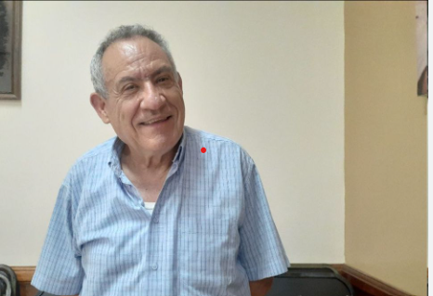
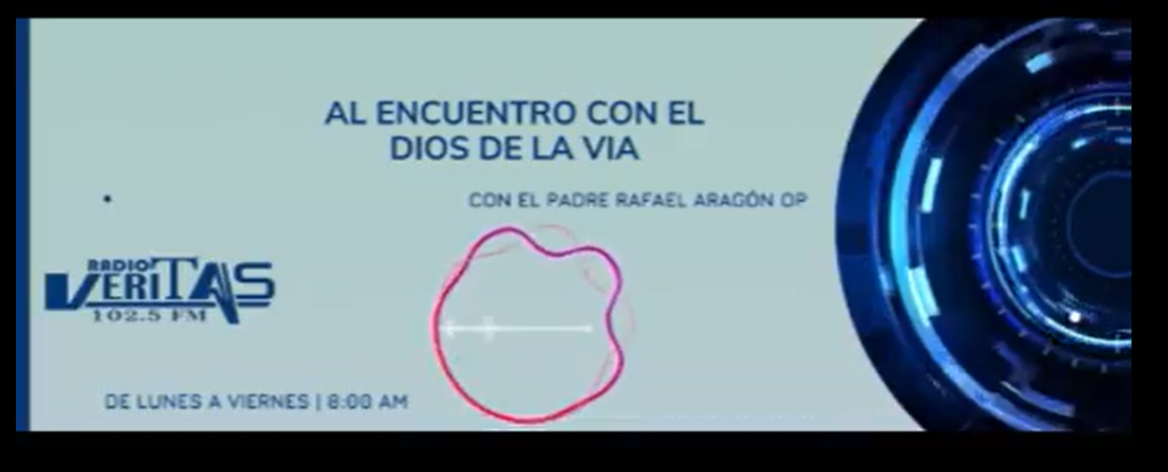https://www.facebook.com/watch/live/?mibextid=xfxF2i&ref=watch_permalink&v=969098748039371&rdid=EEEglZroNLHtzzki

