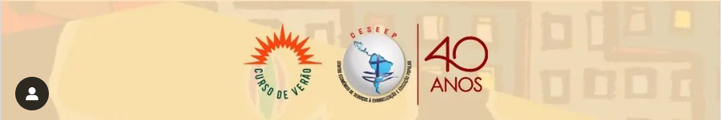
https://mail.google.com/mail/u/1/#inbox/FMfcgzGrbvJjZQnhsrBMNnKqMdKpNBjq?projector=1
https://mail.google.com/mail/u/1/#inbox/FMfcgzGrbvJjZQnhqdnQgMXskrrlBxnK?projector=1

