COMUNICADO
Alto a los desalojos contra comunidades Mayas y respeto a los derechos de los Pueblos Indígenas sobre sus tierras, territorios y recursos

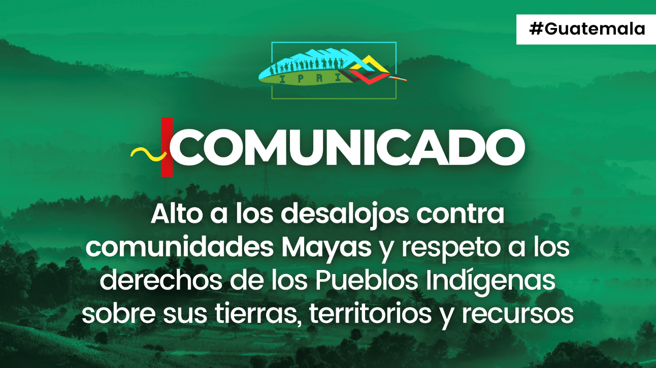

La organización internacional Derechos de los Pueblos Indígenas Internacional (IPRI, por sus siglas en inglés), cuya misión es hacer frente a la violencia y a la criminalización contra los pueblos indígenas, hace un llamado urgente al Estado de Guatemala para que detenga los desalojos y las agresiones de las fuerzas de seguridad contra las comunidades maya Poqomchi y maya Q’eqchi de Sierra de Minas, municipio de Purulha, Baja Verapaz. El Gobierno de Guatemala debe reconocer, respetar y proteger los derechos de los pueblos indígenas sobre sus territorios ancestrales.
De acuerdo con información que se nos ha hecho llegar directamente desde la zona mencionada, desde el pasado 21 de noviembre las y los habitantes de al menos 15 de comunidades indígenas estuvieron bajo un cerco militar y de la Policía Nacional Civil. Este cerco buscaba la detención de líderes indígenas mayas y el desalojo forzado de sus tierras en favor de finqueros, específicamente de la familia Thomae, y de la instalación de empresas extractivistas.
El cerco de las fuerzas de seguridad afectó directamente a 15 comunidades -entre ellas: Pancoc, Monjón, Santa Rita, Washington, Dos Fuentes, Kalijá y Moxante- e impactó indirectamente a 80 comunidades más. Habitantes de las comunidades de Pancoc y Monjón se vieron obligadas a huir de sus hogares ante la violenta incursión de las fuerzas de seguridad.
Aunque el cerco de más de 2 mil policías y militares fue retirado, las amenazas de desalojo continúan y un grupo de civiles armados al servicio de los finqueros continúa atemorizando a las comunidades. También permanece el destacamento militar instalado desde 2012 en las tierras ocupadas por los terratenientes.
De acuerdo con testimonios de las y los habitantes, los policías y los militares quemaron propiedades y ganado de los indígenas mayas. Impidieron su libre circulación, incluyendo la entrada de bienes, aterrorizaron a las comunidades e impidieron que las personas vendieran sus productos agrícolas y obtuvieran alimentos y servicios de salud.
Estas graves violaciones a los derechos individuales y colectivos de las y los indígenas mayas continúan a pesar de que la Comisión Interamericana de Derechos Humanos (CIDH) emitió el 14 de octubre de 2020 la Resolución 67/2020, mediante la cual otorgó medidas cautelares a favor de familias indígenas maya Poqomchi´ de las comunidades Washington y Dos Fuentes. La resolución advirtió de una situación de urgencia por la que los derechos a la vida e integridad personal están en riesgo.
Estas acciones incluyen el desconocimiento absoluto del derecho colectivo de los pueblos indígenas mayas sobre sus tierras ancestrales, teritorios y recursos y su derecho a reclamar y recuperar legítimamente sus tierras ancestrales. Estas tierras les fueron arrebatadas en favor de finqueros alemanes desde 1800, ignorando los títulos que reconocen la propiedad comunal de las comunidades mayas desde tiempos de la Corona española y la independencia, y reclamando en cambio esta propiedad comunal como propiedad privada. Las acciones emprendidas por los indígenas mayas para proteger y defender sus territorios han incluido tanto el litigio judicial como la afirmación de su derecho a la autonomía y el rechazo a la instalación de proyectos extractivistas, como hidroeléctricas.
Las legítimas demandas de estas comunidades indígenas han sido respondidas con acciones injustas por parte de las autoridades y los finqueros con una serie de intentos de desalojo en los años 2009, 2015, 2021 y 2022. Las comunidades que en concreto han sido objeto de estos intentos son Washington, Dos Fuentes y Panzal, Estas comunidades han sido objeto de desapariciones, criminalización, asesinato de líderes comunitarios e instalación de destacamentos militares. La situación ha empeorado con la llegada del crimen organizado, que se ha asentado sobre las estructuras paramilitares responsables de masacres durante el periodo de la contrainsurgencia.
Las comunidades han denunciado que la militarización de su territorio no ha buscado proporcionarles seguridad, sino garantizar la implantación de proyectos extractivistas y el despojo de sus tierras por los finqueros.
En este contexto, y considerando las obligaciones internacionales en materia de derechos humanos del Estado guatemalteco a la luz de la adopción de la Declaración de las Naciones Unidas sobre los derechos de los pueblos indígenas, de la Declaración Americana sobre los Derechos de los Pueblos Indígenas, del Convenio 169 de la OIT y del propio marco constitucional guatemalteco, IPRI:
- Apoya la demanda urgente de desmilitarización de Sierra de Mina expresada por las comunidades indígenas mayas afectadas.
- Exige al Estado de Guatemala el cese inmediato de las órdenes de desalojo, así como de la violencia y la criminalización contra las comunidades mencionadas.
- Insta a las autoridades responsables a cumplir las medidas cautelares emitidas por la CIDH en 2020.
- Exige el desmantelamiento de los grupos civiles armados al servicio de los finqueros que amenazan a las comunidades indígenas.
- Pide el reconocimiento legal, la restitución y la protección de las tierras ancestrales de los pueblos indígenas mayas por parte del Estado de Guatemala, y que se establezca un mecanismo efectivo de rendición de cuentas para quienes han violado derechos humanos.
Instamos a las organizaciones internacionales de derechos humanos a que llamen la atención sobre esta situación urgente y se unan a nosotros para exigir al Estado de Guatemala que actúe urgentemente para proteger los derechos individuales y colectivos de los pueblos indígenas mayas.
También instamos a la comunidad internacional a expresar su solidaridad con los pueblos indígenas mayas y a instar al Estado de Guatemala a que respete, reconozca y proteja sus derechos individuales y colectivos y ponga fin a las violaciones impunes de los derechos humanos.

📢 Stop evictions against Mayan communities and respect Indigenous People's rights over the lands, territories, and resources (mailchi.mp)

