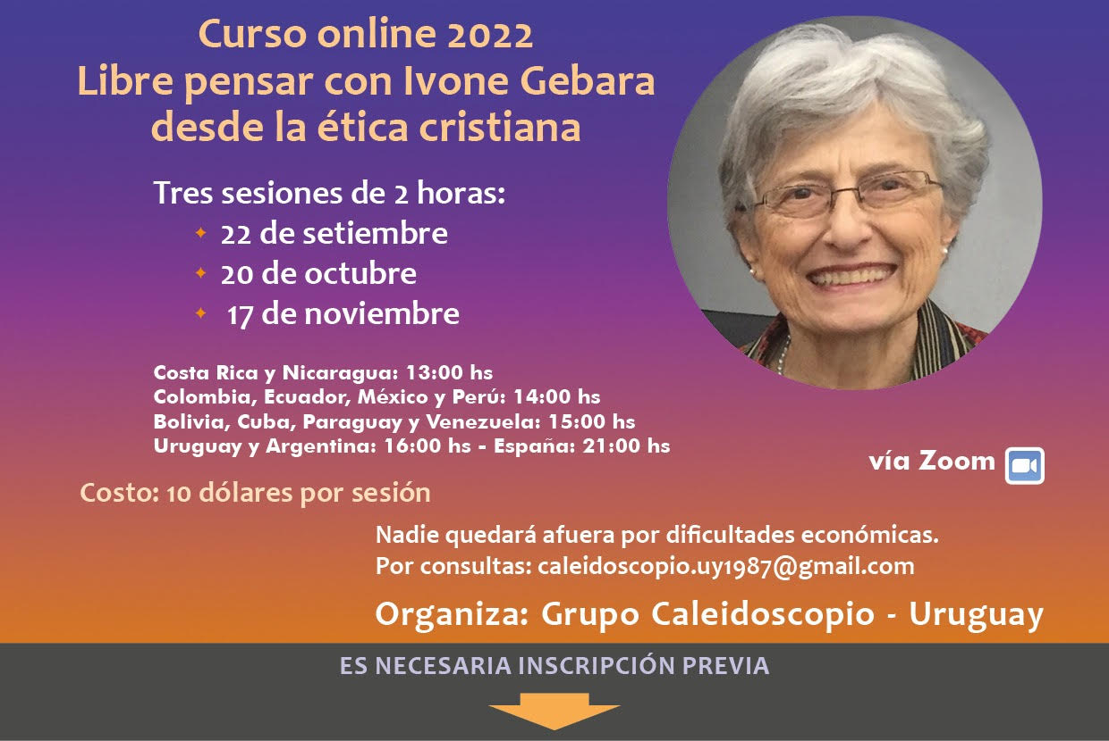

https://forms.gle/FNXDYVUqh7fnQEUy9