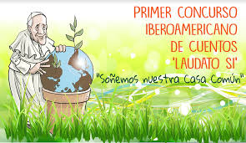

https://cuentoslaudatosi.org/
https://www.vaticannews.va/es/mundo/news/2020-07/primer-concurso-iberoamericano-de-cuentos-laudato-si-papa.html
https://www.youtube.com/watch?v=Mgpj4gxUy6o

https://youtu.be/Mgpj4gxUy6o
