Pope Francis’ words of hope for Our Common Home
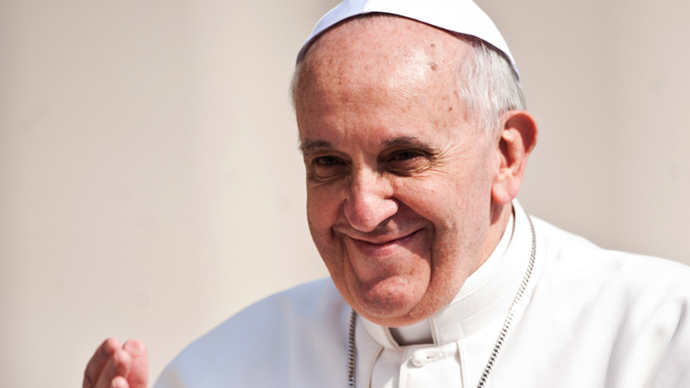
Catherine from our Theology team reflects on the climate emergency facing the Earth, our common home, its impact on the lives of those who are poorest, and how Pope Francis’ encyclical Laudato Si’ offers hope and inspiration for action.
My children, aged two and four, find nature endlessly fascinating. The short walk to nursery often involves stopping to pick up sticks, stones and leaves. Other times we have to get down on our knees to peer at an ant or a worm that is crossing our path. We never get anywhere quickly.
We talk about the birds, squirrels and foxes we see in our garden or the park. In autumn the children were fascinated by the changing colour of the leaves. This spring, they asked why the trees were suddenly covered in flowers.
Through them I see the world differently. Nature is not just background to their lives. It is a vital part.

Creation is a gift
They seem to know instinctively something which I profess to believe, but often forget. Creation is a gift from God, full of beauty and wonder. It is something that can fill us with joy and which we are part of and connected to. And we are called to care for it and all who live in it.
It is our common home – created for all to share and enjoy.
Give thanks to God for the gift of our common home. Use our prayers to inspire you.
We believe that God created the Earth and all it contains out of love. And God saw that it was good. But our relationships with God, the Earth and each other have broken down.

The challenge facing our common home
All around the world, including in England and Wales, we are already experiencing the effects of climate change. Our sisters and brothers around the world who have done the least to cause the problem are really struggling.
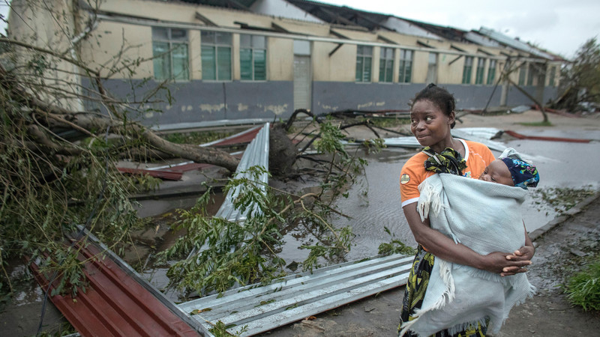Buildings where people had sought shelter were damaged during Cyclone Idai. Photo by Josh Estey/CARE.
Floods, droughts, cyclones and other extreme weather are taking their toll. This is undoing the work we have done together to fight poverty. As the climate worsens, hunger, migration and conflict will become more common.
As Pope Francis says in his encyclical Laudato Si’: “Climate change … represents one of the principal challenges facing humanity in our day. … Many of the poor live in areas particularly affected by … warming … They have no other financial activities or resources which can enable them to adapt to climate change or to face natural disasters, and their access to social services and protection is very limited. For example, changes in climate, to which animals and plants cannot adapt, lead them to migrate; this in turn affects the livelihood of the poor, who are then forced to leave their homes, with great uncertainty for their future and that of their children. … they bear the loss of the lives they have left behind, without enjoying any legal protection whatsoever.” (#25)
The thought of what we are doing to the earth, our global neighbours, and future generations paralyses me. The problem seems so huge and I don’t know where to begin. We have plundered this gift and destroyed it, so that it starts to look like “an immense pile of filth.” (Laudato Si’ #21)

Words of hope in Laudato Si’
But when my despair at the state of the world is at its greatest, and I feel full of fear about what the future holds, other words from Pope Francis in Laudato Si’ give me hope:
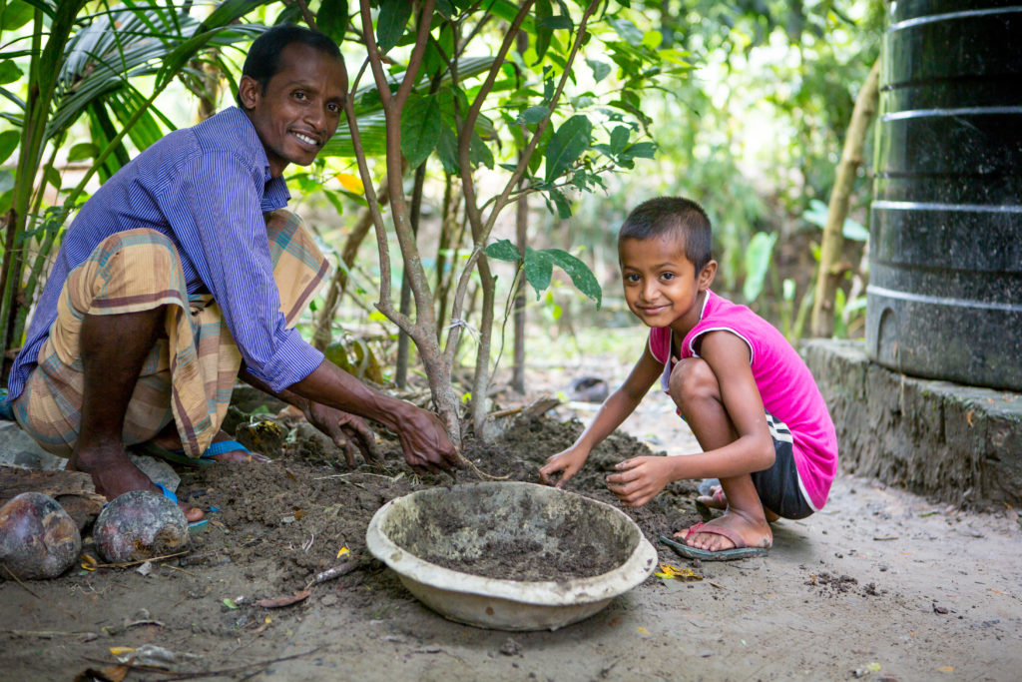Suchandra and his son looking after saplings in their garden in Bangladesh.
“The Creator does not abandon us; he never forsakes his loving plan or repents of having created us. Humanity still has the ability to work together in building our common home.” (#13)
Take action today. Call on the Prime Minister to put an end to the UK’s contribution to climate change.

Recreating the future
It is time to renew our relationships with God, the Earth and each other. We cannot solve anything alone. We need to work together to find solutions. We need to look at the whole picture, reimagine our world and how we live in it, and recreate the future as one of hope.
Our faith calls us to action. Care for creation is not an add on to our faith. It is a fundamental part of it. From Genesis, to the Gospels, to St Francis, to today, the Scriptures, the lives of saints and Catholic social teaching speak to us of the importance of caring for the world around us and for those who are most vulnerable in our society.
In the face of this how can we stand by and do nothing?
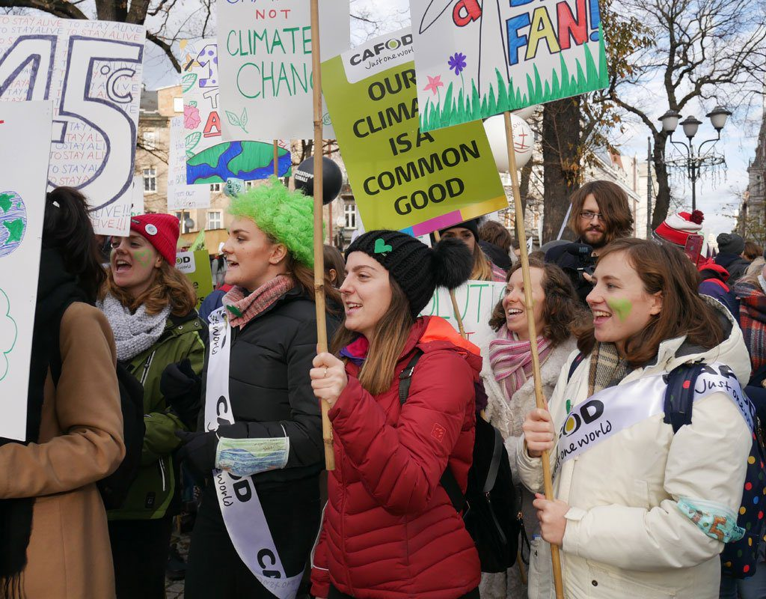CAFOD campaigners march for our planet
We are called “to hear both the cry of the earth and the cry of the poor.” (Laudato Si’ #49) And hearing this cry we must respond.
Pope Francis says: “I urgently appeal, then, for a new dialogue about how we are shaping the future of our planet. We need a conversation which includes everyone, since the environmental challenge we are undergoing, and its human roots, concern and affect us all…. All of us can cooperate as instruments of God for the care of creation, each according to his or her own culture, experience, involvements and talents.” (Laudato Si’ #14)
Let’s start that conversation today.
Join the conversation. Organise a Creation Celebration in your parish or group.

https://blog.cafod.org.uk/2019/05/27/pope-francis-words-of-hope-for-our-common-home/

